课程名称＿数据结构 实验名称＿二叉树的创建和遍历 实验日期＿2019.4＿＿＿＿＿＿
班 级＿计科1805 姓 名＿＿吕思颖＿＿ 学号＿1033180511＿ 仪器编号＿＿＿＿＿＿
实验报告要求 1.实验目的 2.实验要求 3.实验步骤 4.程序清单 5.运行情况 6.流程图 7.实验体会
实验目的：
⑴ 熟悉二叉树的定义和基本操
⑵ 掌握二叉树的链式存储结构设计与基本操作的实现
实验内容：
1、采用书上第 127 页定义的二叉树的二叉链表存储表示，编写递归算法实现二叉树的下列基本操作。
（1）构造二叉树
（2）复制二叉树
（3）销毁二叉树
（4）先序遍历二叉树
（5）中序遍历二叉树
（6）后序遍历二叉树
（7）求二叉树的深度
（8）求二叉树的结点数
（9）求二叉树的叶子结点数
（10）交换二叉树的左右子树
2、采用书上第 127 页定义的二叉树的二叉链表存储表示，编写非递归算法实现二叉树的下列基本操作。
（1）构造二叉树
（2）先序遍历二叉树
（3）中序遍历二叉树
（4）后序遍历二叉树
（5）层次遍历二叉树
（6）求二叉树的深度
（7）求二叉树的叶子结点数
（8）交换二叉树的左右子树
程序清单：
1.
#include<stdio.h>
#include<stdlib.h>
#include<stdarg.h>
#include<math.h>
#define OK 1
#define ERROR 0
#define FALSE 0
#define TRUE 1
#define OVERFLOW -2
typedef struct BITNODE
{
char data;
struct BITNODE *left, *right;
}BITNODE, *BITREE;

int num = 0;
int c = 0;
int create(BITREE &T)
{
char ch;
scanf("%c", &ch);
if (ch == ' ')T = NULL;
else
{
if (!(T = (BITNODE*)malloc(sizeof(BITNODE))))exit(OVERFLOW);
T->data = ch;
create(T->left);
create(T->right);
}
return OK;
}//createtree

int preorder(BITREE T)
{
if (T)
{
printf("%c", T->data);
if (preorder(T->left));
if (preorder(T->right))return OK;
return ERROR;
}
else return OK;
}//PreORderTraverse

int inorder(BITREE T)
{
int m = 0;
if (T)
{
if (inorder(T->left))m = 1;
printf("%c", T->data);
if (m)
if (inorder(T->right))return OK;
return ERROR;
}
else return OK;
}//InOrderTraverse

int postorder(BITREE T)
{
if (T)
{
if (postorder(T->left))
if (postorder(T->right))
{
printf("%c", T->data);
return OK;
}
return ERROR;
}
else return OK;
}//PostOrderTraverse

int Depth(BITREE T)
{
int leftDepth, rightDepth;
if (T == NULL)return 0;
else
{
leftDepth = Depth(T->left);
rightDepth = Depth(T->right);
if (leftDepth >= rightDepth)return leftDepth + 1;
else return rightDepth + 1;
}
}

int NodeCount(BITREE T)
{
if (T)
{
num++;
if (NodeCount(T->left))
if (NodeCount(T->right))return OK;
return ERROR;
}
else return OK;
}//NodeCount

int LeftCount(BITREE T)
{
if (T)
{
if (T->left == NULL && T->right == NULL)
{
printf("%c", T->data);
c = c + 1;
}
if (LeftCount(T->left))
if (LeftCount(T->right))return OK;
return ERROR;
}
else return OK;
}//LeafCount

int Exchange(BITREE &T)
{
BITREE p;
if (T)
{
if (T->left || T->right)
{
p = T->left;
T->left = T->right;
T->right = p;
}
if (Exchange(T->left))
if (Exchange(T->right))return OK;
return ERROR;
}
else return OK;
}//ExchangeBiTree

int copy(BITREE T, BITREE &B)
{
if (T == NULL)B = NULL;
else
{
if (!(B = (BITNODE*)malloc(sizeof(BITNODE))))exit(OVERFLOW);
B->data = T->data;
copy(T->left, B->left);
copy(T->right, B->right);
}
return OK;
}//CopyBiTree

int destroy(BITREE &T)
{
if (T)
{
destroy(T->left);
destroy(T->right);
free(T);
}
return OK;
}//DestroyTree

int clear(BITREE &T)
{
if (T)
{
T = NULL;
}
return OK;
}//ClearTree

int main()
{
BITREE T, B;
printf("创建二叉树，按先序次序输入二叉树中节点的值：\n");
create(T);
NodeCount(T);
printf("二叉树的节点个数为：%d\n", num);
printf("二叉树的深度为：%d\n", Depth(T));
printf("先序遍历二叉树，结果是：\n");
preorder(T);
printf("\n");
printf("中序遍历二叉树，结果是：\n");
inorder(T);
printf("\n");
printf("后序遍历二叉树，结果是：\n");
postorder(T);
printf("\n");
printf("输出二叉树的叶子节点：\n");
LeftCount(T);
printf("\n");
printf("统计二叉树的叶子节点个数：%d\n", c);
printf("交换二叉树中所有节点的左右子树！\n");
Exchange(T);
if (copy(T, B) == OK)printf("成功复制二叉树T到二叉树B！\n");
if (destroy(T) == OK)printf("成功销毁二叉树T!\n");
if (clear(T) == OK)printf("将二叉树T置为空树！\n");
printf("先序遍历二叉树B，结果是：\n");
preorder(T);
printf("\n");
printf("中序遍历二叉树B，结果是：\n");
inorder(T);
printf("\n");
printf("后序遍历二叉树B，结果是：\n");
postorder(T);
printf("\n");
}
1.
#include <stdio.h>
#include <stdlib.h>
#define TURE 1
#define FLASE 0
#define OK 1
#define ERROR 0
#define OVERFLOW -2
#define STACK_INIT_SIZE 100
#define STACKINCREMENT 10
#define MAX_TREE_SIZE 100
typedef char TElemType;
typedef struct BiTNode
{
TElemType data;
struct BiTNode *lchild, *rchild;
}BiTNode, *BiTree;
typedef int Status;
typedef char SElemType;
typedef struct
{
BiTree *base;
BiTree *top;
int stacksize;
}SqStack;
Status InitStack(SqStack &S)
{
S.base = (BiTree *)malloc(STACK_INIT_SIZE * sizeof(BiTree));
if (!S.base) exit(OVERFLOW);
S.top = S.base;
S.stacksize = STACK_INIT_SIZE;
return OK;
}
Status Push(SqStack &S, BiTree e)
{
if (S.top - S.base >= S.stacksize)
{
S.base = (BiTree *)realloc(S.base, (S.stacksize + STACKINCREMENT) * sizeof(BiTree));
if (!S.base)exit(OVERFLOW);
S.top = S.base + S.stacksize;
S.stacksize += STACKINCREMENT;
}
*S.top++ = e;
return OK;
}
Status Pop(SqStack &S, BiTree &e)
{
if (S.top == S.base) return ERROR;
e = *--S.top;
return OK;
}
Status GetTop(SqStack S, BiTree &e)
{
if (S.top == S.base) return ERROR;
e = *(S.top - 1);
return OK;
}
Status StackEmpty(SqStack S)
{
if (S.base == S.top) return OK;
else
return ERROR;
}
typedef BiTree QElemType;
typedef struct QNode
{
QElemType data;
struct QNode *next;
}QNode, *QueuePtr;
typedef struct
{
QueuePtr front;
QueuePtr rear;
}LinkQueue;
Status InitQueue(LinkQueue &Q)
{
Q.front = Q.rear = (QueuePtr)malloc(sizeof(QNode));
if (!Q.front) exit(OVERFLOW);
Q.front->next = NULL;
return OK;
}
Status EnQueue(LinkQueue &Q, QElemType e)
{
QueuePtr p;
p = (QueuePtr)malloc(sizeof(QNode));
if (!p) exit(OVERFLOW);
p->data = e;
p->next = NULL;
Q.rear->next = p;
Q.rear = p;
return OK;
}
Status DeQueue(LinkQueue &Q, QElemType &e)
{
QueuePtr p;
if (Q.front == Q.rear) return ERROR;
p = Q.front->next;
e = p->data;
Q.front->next = p->next;
if (Q.rear == p) Q.rear = Q.front;
free(p);
return OK;
}
Status EmptyQueue(LinkQueue Q)
{
if (Q.front == Q.rear) return 1;
else
return 0;
}
Status LenQueue(LinkQueue Q)
{
if (Q.front == NULL) exit(OVERFLOW);
int length = 0;
QueuePtr p = Q.front->next;
while (p != NULL)
{
length++;
p = p->next;
}
return length;
}
Status Gethead(LinkQueue Q, QElemType &e)
{
if (Q.front == NULL) exit(OVERFLOW);
e = Q.front->data;
return OK;
}
Status CreateBiTree(BiTree &T, SqStack &S)
{
TElemType ch;
if (!(T = (BiTNode *)malloc(sizeof(BiTNode)))) exit(OVERFLOW);
scanf("%c", &ch);
T->data = ch;
Push(S, T);
while (!StackEmpty(S))
{
scanf("%c", &ch);
if (ch != '#')
{
T->lchild = (BiTNode *)malloc(sizeof(BiTNode));
T->lchild->data = ch;
Push(S, T->lchild);
}
else
T->lchild = NULL;
scanf("%c", &ch);
if (ch != '#')
{
T->rchild = (BiTNode *)malloc(sizeof(BiTNode));
T->rchild->data = ch;
Push(S, T->rchild);
}
else
T->rchild = NULL;
Pop(S, T);
}
return OK;
}
Status PreOrderTraverse(BiTree T, SqStack S)
{
BiTree p = T;
InitStack(S);
Push(S, p);
while (!StackEmpty(S))
{
if (p != NULL)
{
Push(S, p);
printf("%c", p->data);
p = p->lchild;
}
else
{
Pop(S, p);
p = p->rchild;
}
}
return OK;
}
Status InOrderTraverse(BiTree T, SqStack S)
{
BiTree p = T;
while (p || !StackEmpty(S))
{
if (p) { Push(S, p); p = p->lchild; }
else
{
Pop(S, p);
printf("%c", p->data);
p = p->rchild;
}
}
return OK;
}
Status PostTraverse(BiTree T, SqStack S)
{
BiTree cur, pre;
if (T == NULL)
{
printf("The tree is empty！\n");
exit(OVERFLOW);
}
pre = NULL; cur = NULL;
Push(S, T);
while (!StackEmpty(S))
{
cur = NULL;
GetTop(S, cur);
if ((cur->lchild == NULL && cur->rchild == NULL) || (pre != NULL && (pre == cur->lchild || pre == cur->rchild)))
{
printf("%c", cur->data);
pre = cur;
Pop(S, cur);
}
else
{
if (cur->rchild != NULL)
{
Push(S, cur->rchild);
}
if (cur->lchild != NULL)
Push(S, cur->lchild);
}
}
return OK;
}//待改善
Status LevelTraverse(BiTree T)
{
LinkQueue Q;
BiTree p;
p = T;
InitQueue(Q);
if (p == NULL) exit(OVERFLOW);
EnQueue(Q, p);
while (!EmptyQueue(Q)) {
p = NULL;
DeQueue(Q, p);
if (p->lchild != NULL)
EnQueue(Q, p->lchild);
if (p->rchild != NULL)
EnQueue(Q, p->rchild);
printf("%c", p->data);
}
return OK;
}
Status TreeDepth(BiTree T)
{
LinkQueue Q;
InitQueue(Q);
if (T == NULL) exit(OVERFLOW);
EnQueue(Q, T);
BiTree p;
int level = 0;
int len = 0;
while (!EmptyQueue(Q))
{
len = LenQueue(Q);
level++;
while (len--)
{
DeQueue(Q, p);
if (p->lchild) EnQueue(Q, p->lchild);
if (p->rchild) EnQueue(Q, p->rchild);
}
}
printf("%d", level);
return OK;
}
Status Nodecount(BiTree T, SqStack S)
{
BiTree p = T;
int len = 0;
while (p || !StackEmpty(S))
{
if (p) { Push(S, p); p = p->lchild; }
else
{
Pop(S, p);
len++;
p = p->rchild;
}
}
printf("%d", len);
return OK;
}
void ExchangeBiTree(BiTree &T)
{
LinkQueue Q;
InitQueue(Q);
if (T == NULL)
exit(OVERFLOW);
EnQueue(Q, T);
while (!EmptyQueue(Q))
{
BiTree p;
DeQueue(Q, p);
if (p->lchild != NULL)
EnQueue(Q, T->lchild);
if (p->rchild != NULL)
EnQueue(Q, T->lchild);
BiTree temp;
temp = p->lchild;
p->lchild = p->rchild;
p->rchild = temp;
}
}
int main()
{
BiTree T;
SqStack S;
InitStack(S);
printf("Create a BiTree!:\n");
CreateBiTree(T, S);
printf("PreOrderTraver the BiTree!:\n");
PreOrderTraverse(T, S);
printf("\n");
printf("InOrderTraverse the BiTree!:\n");
InOrderTraverse(T, S);
printf("\n");
printf("PostOderTraverse the BiTree!:\n");
PostTraverse(T, S);
printf("\n");
printf("LevelTraverse the BiTree!:\n");
LevelTraverse(T);
printf("\n");
printf("Get the depth of the Bitree!:\n");
TreeDepth(T);
printf("\n");
printf("Get the total numbers of the Bitree's root!\n");
Nodecount(T, S);
printf("\n");
printf("Exchage the Bitree!\n");
ExchangeBiTree(T);
LevelTraverse(T);
printf("\n");
}
运行情况：
1.
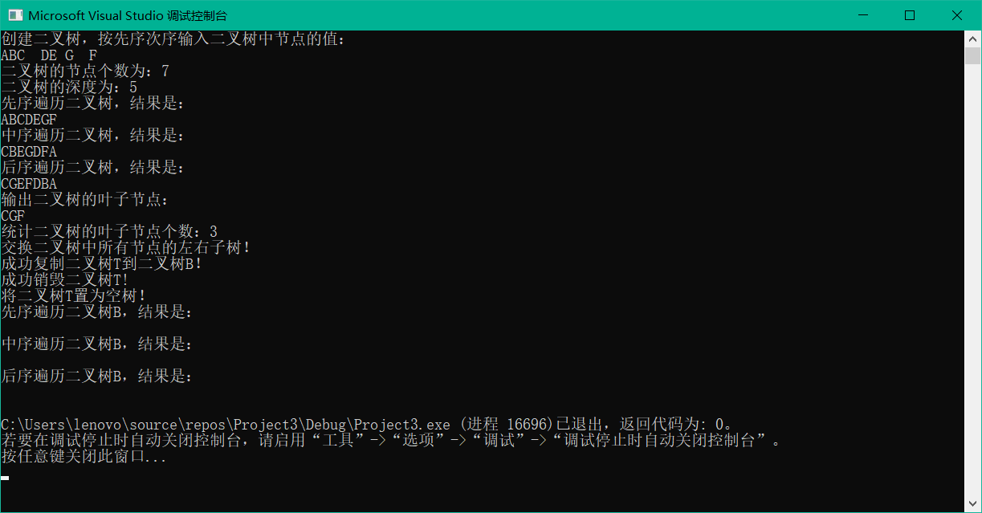
2.
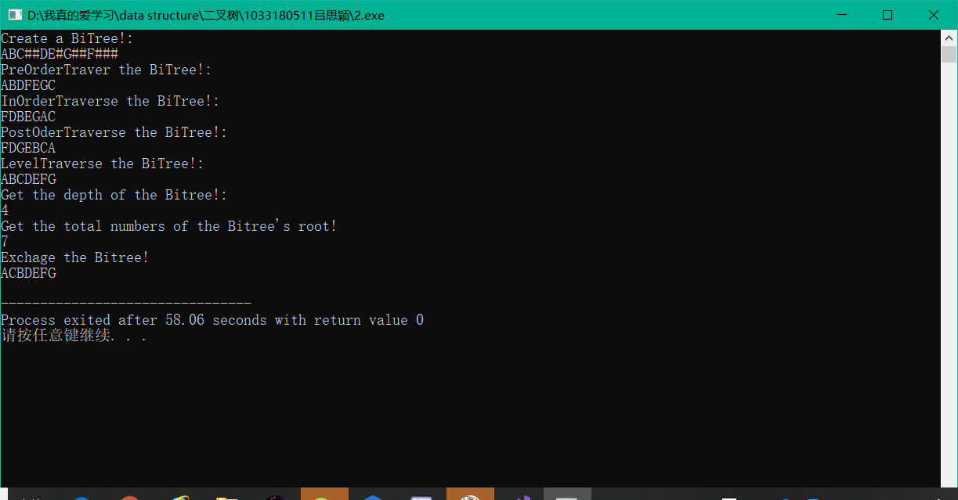
实验体会：
教师评价 | 优 |  | 良 |  | 中 |  | 及格 |  | 不及  格 |  | 教师签名 |  | 日期
江南大学物联网工程学院实验报告

